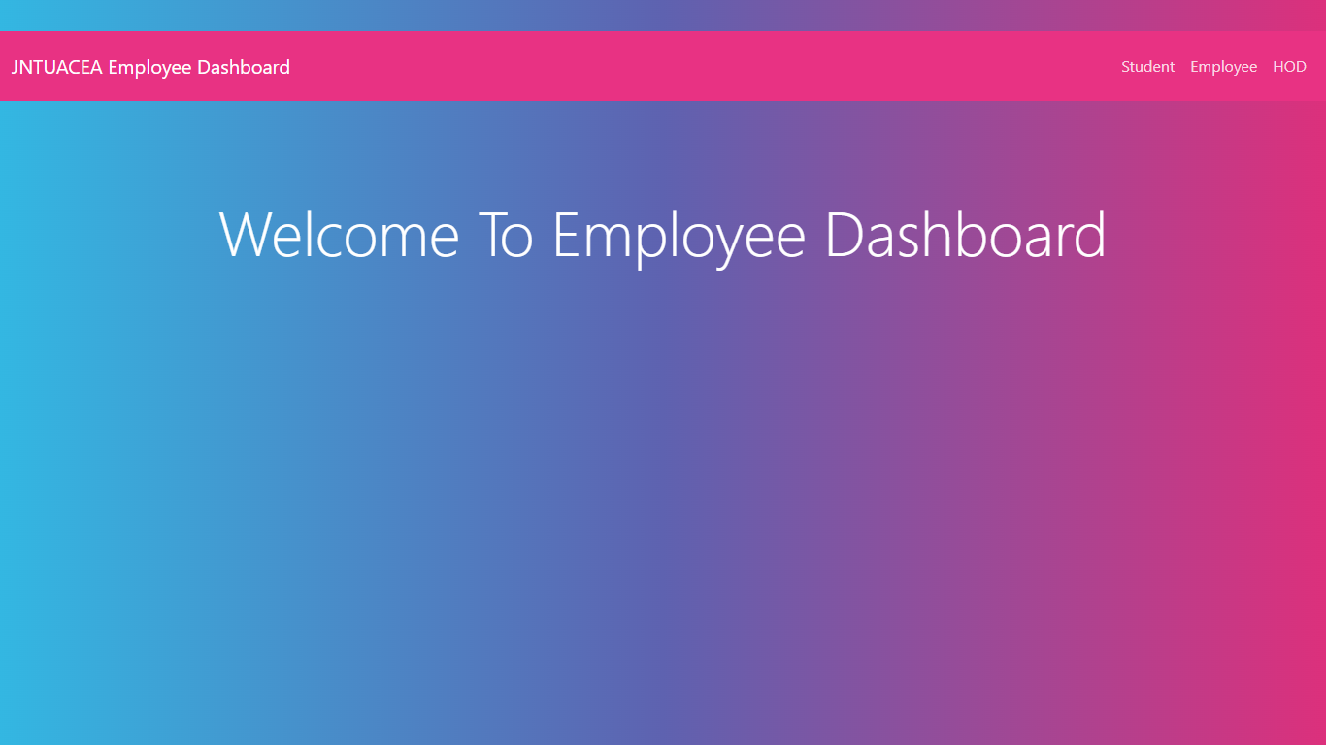

**Home:** This is the home page.

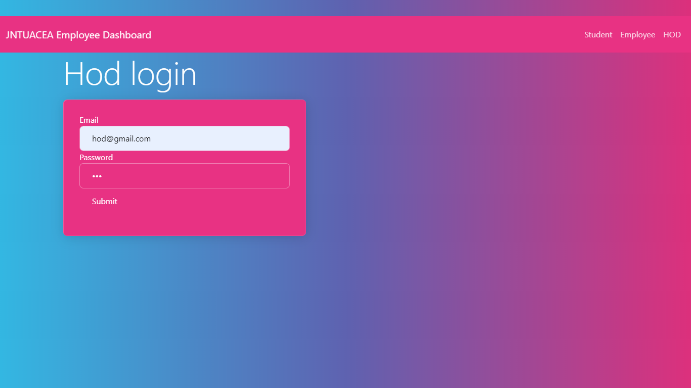

**HOD:** Hod can login with these page with default credentials.

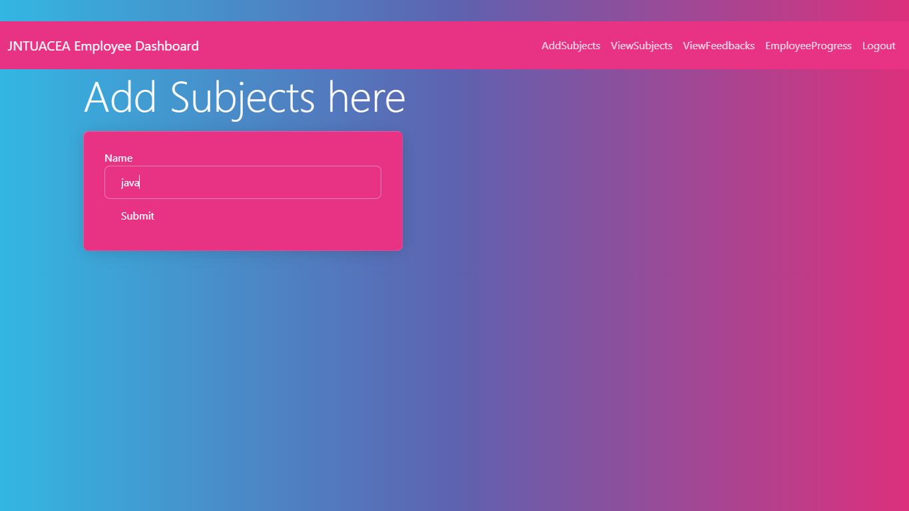

**ADD SUBJECTS:**  In this page hod can add subjects

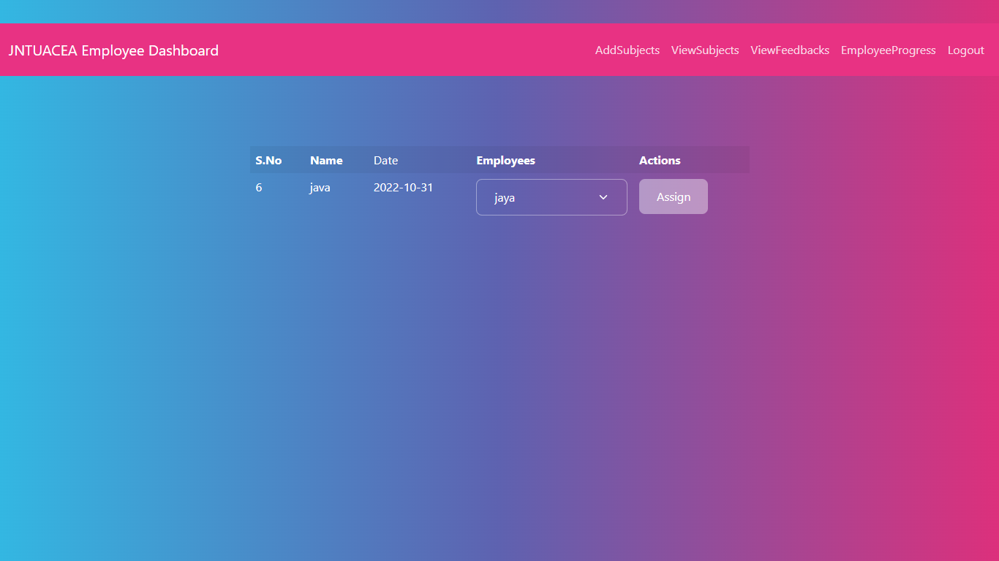

**ASSIGN SUBJECTS :**  In this page hod can assign subjects for a particular employee.

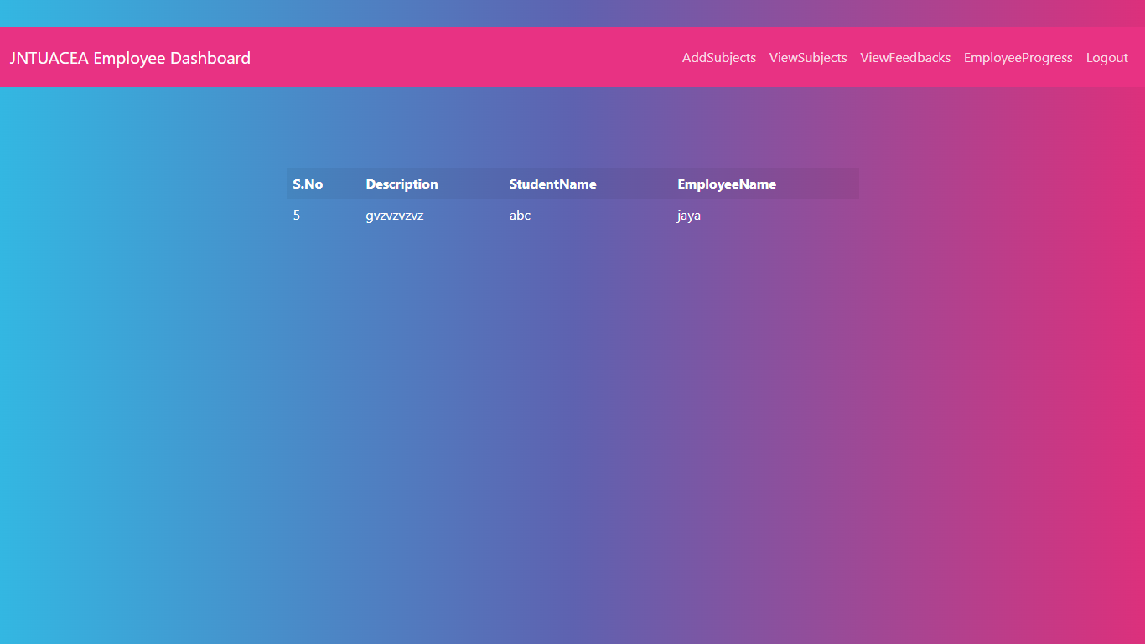

**VIEW FEEDBACKS:**  In this page hod can view feedbacks given by students for employees.

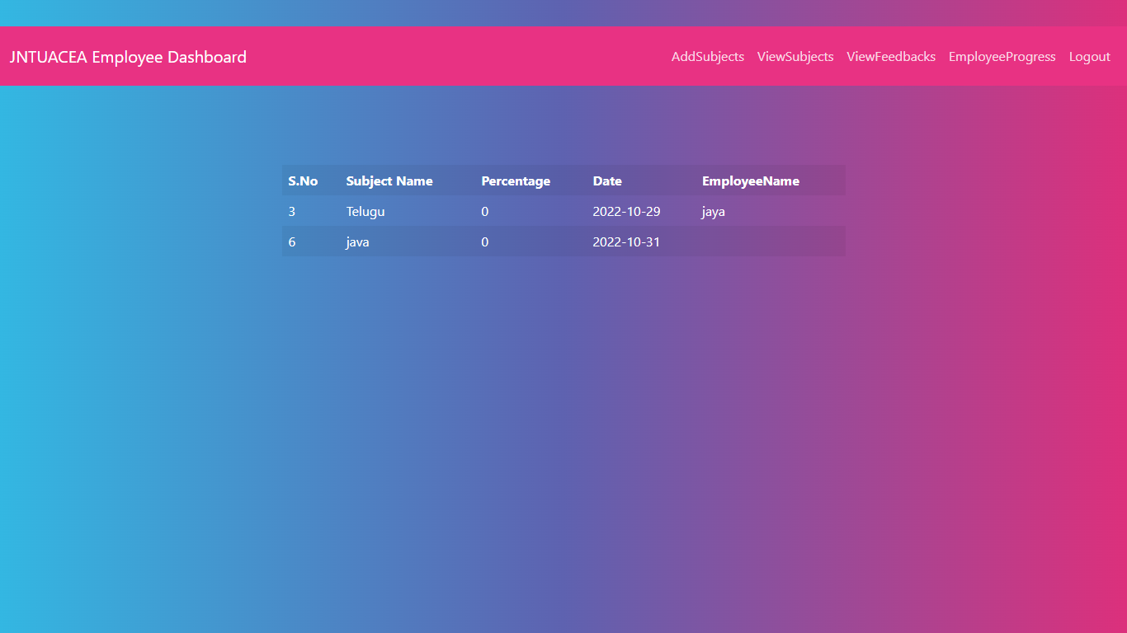

**PROGRESS:** In this page hod can view the progress given by employee.

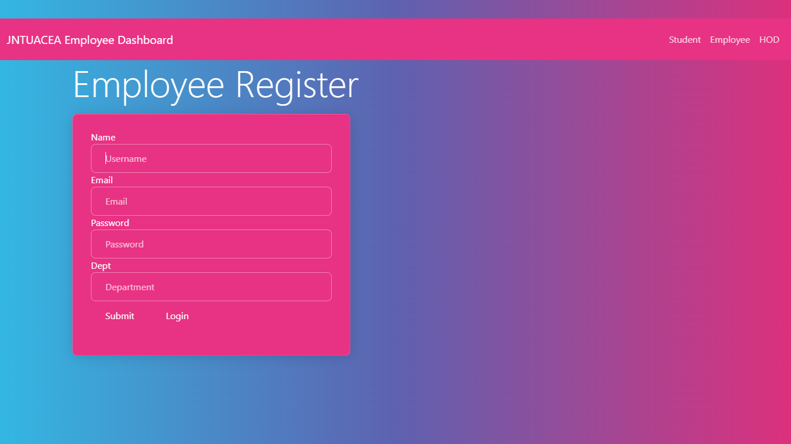

**EMPPLOYEE REGISTER :**  In this page employee can register here.

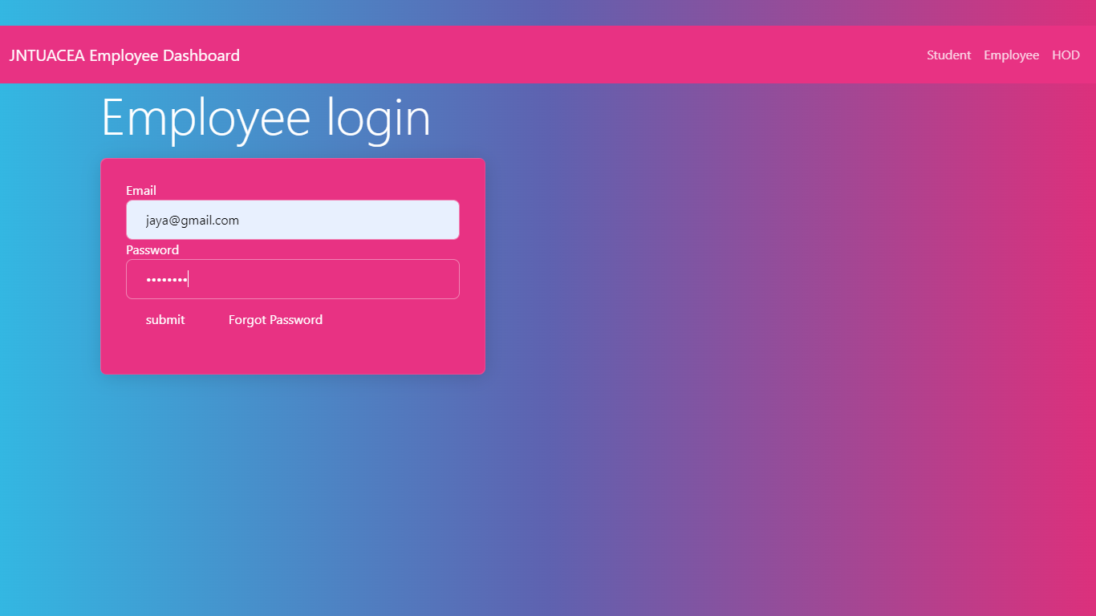

**EMPLOYEE LOGIN:**  In this page employee can login here with their login details

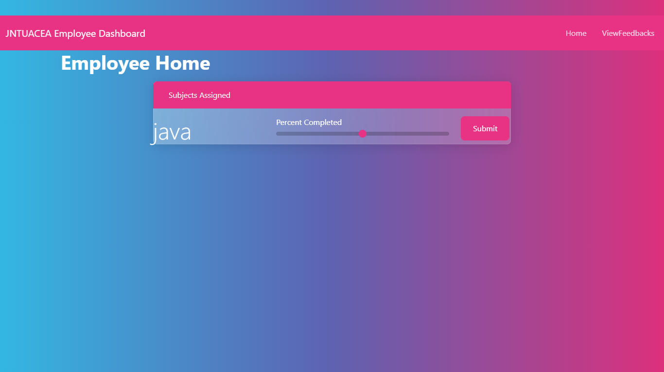

**EMPLOYEE HOME :** Employee can complete the work given by hod and along with view feedbacks given by the students.

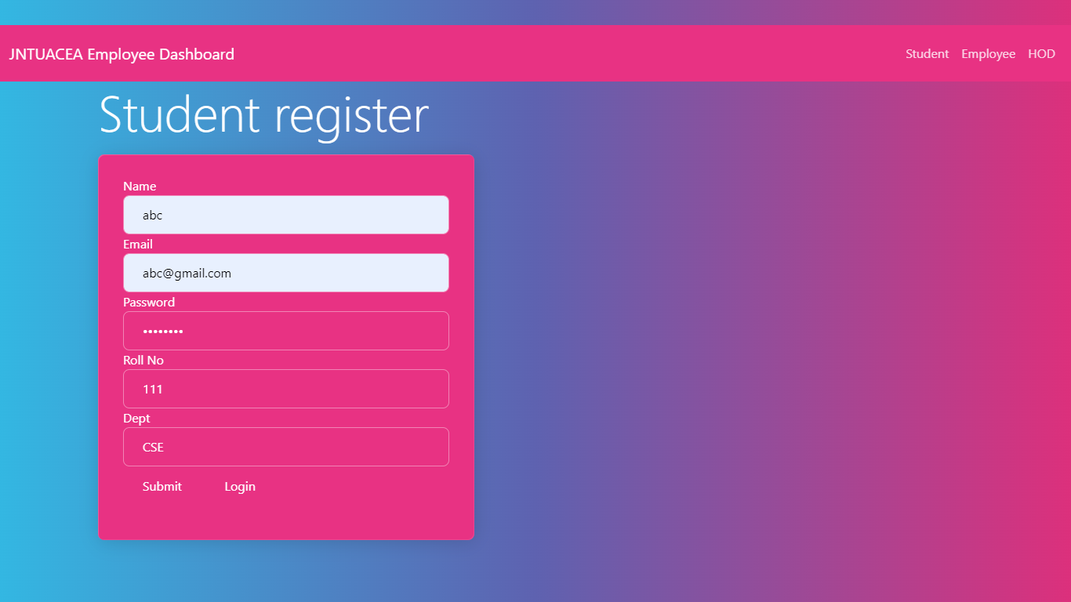

**STUDENT REGISTER:**  In this page student can register with required details

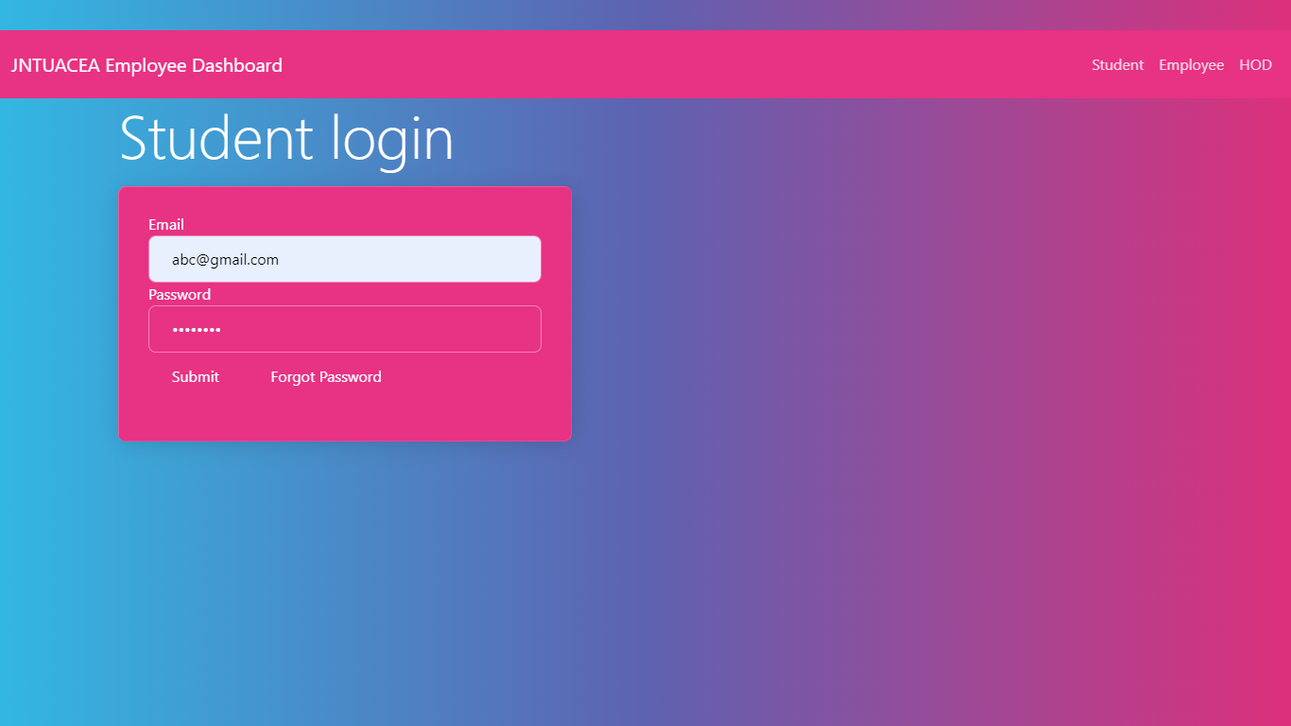

**STUDENT LOGIN :** In this page student can login with their credentials.

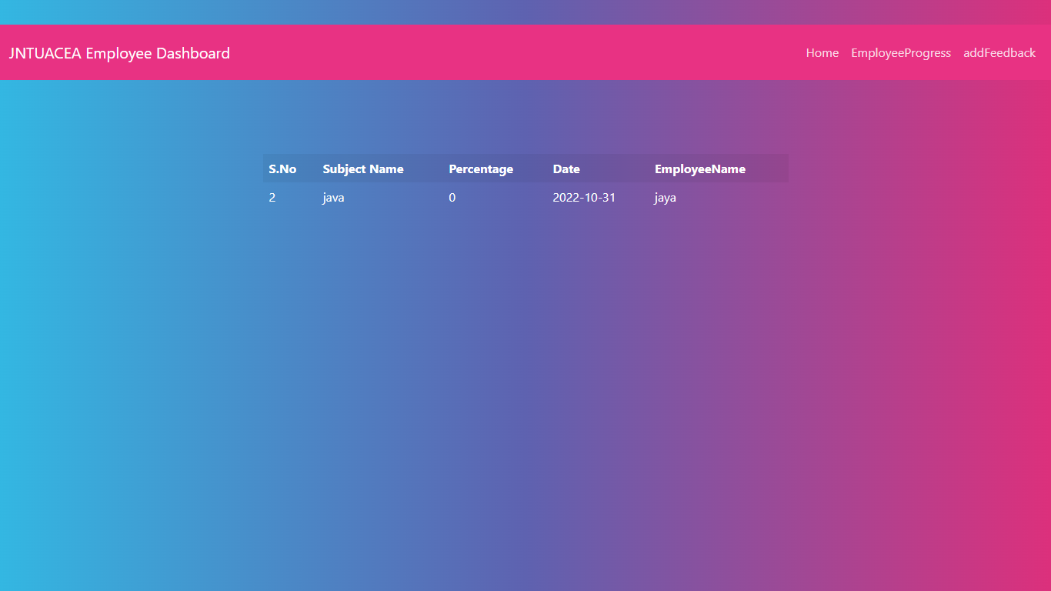

**VIEW PROGRESS :**  In this page student can view employee progress.

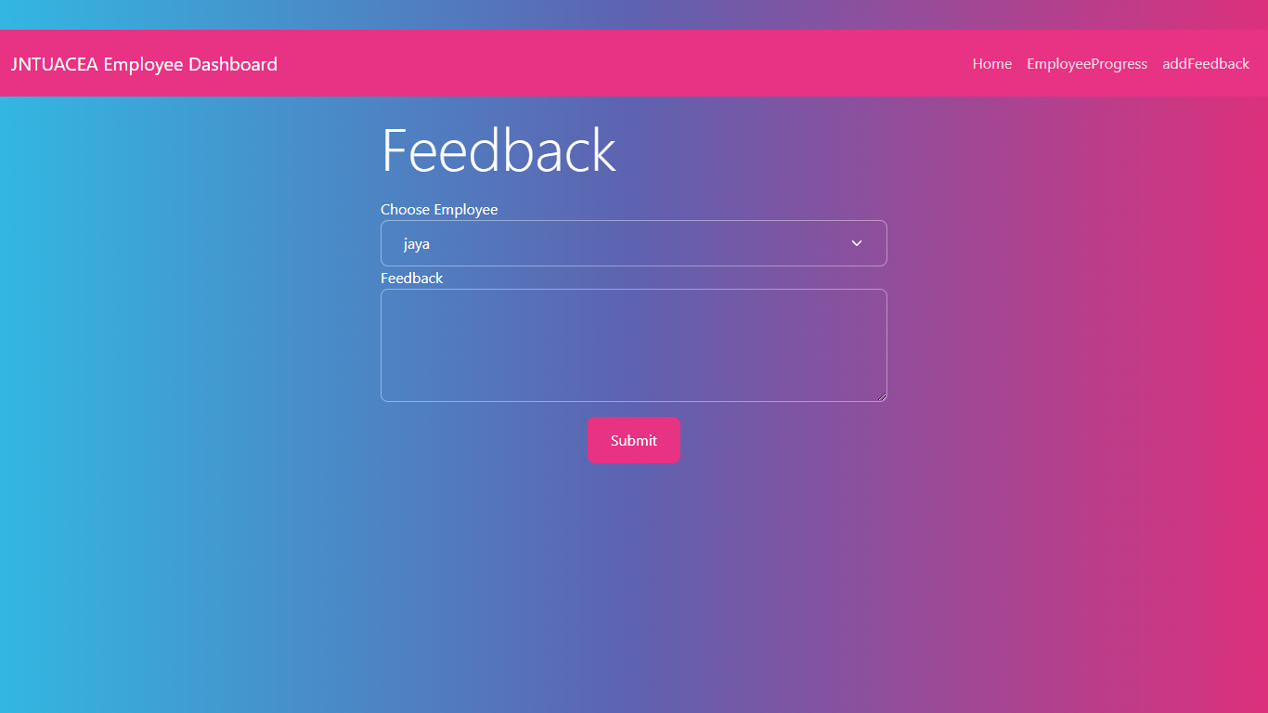

**FEEDBACK:**  In this page student can give feedback with a particular employee.